**MPMS Mockup Design**

version 1.0 ⚫ 16 September 2019

Multi-Package Management System



**Table of Contents**

**1 Introduction** 4

1.1 Purpose 4

1.2 Scope 4

**2 MPMS Login Page** 5

**3 Account Recovery** 6

**4 Admin Landing Page** 8

**5 My account Page** 9

**6 Client Information** 10

6.1 Add Company Information 11

6.2 Add Client Primary Contact 12

6.3 Review Client Information(add) 13

6.4 Update Company Information 14

6.5 Update Client Primary Contact 15

6.6 Review Client Information(update) 16

6.7 View Client Information 17

**7 Contract Information** 18

7.1 Add Contract 19

7.2 Review Contract Information(add) 20

7.3 Update Contract 21

7.4 Review Contract Information(edit) 22

7.5 View Contract Information 23

**8 Service Information** 24

8.1 Add service information 25

8.2 Review Service Information(add) 26

8.3 Update Service Information 27

8.4 Review Service Information(edit) 28

8.5 View Service Information 29

**9 Pricing** 30

9.1 Select Service 31

9.2 Unit Pricing 32

9.3 Promotional Pricing 33

9.4 Review Pricing(add) 34

9.5 Update Unit Price 35

9.6 Update Promotional Price 36

9.7 Review Pricing(update) 37

9.8 View Price Event Information 38

**10 User Information** 39

10.1 Add User Information 40

10.2 Review User Information(add) 41

10.3 Update User Information 42

10.4 Review User Information(update) 43

10.5 View User Information 44

**11 Authorization** 45

11.1 Add Role 46

11.2 Review Role Information(add) 47

11.3 Update Role 48

11.4 Review Role Information(edit) 49

11.5 View Role Information 50

**12 Security Information** 51

12.1 Review Security Information 52

**13 Agency Information** 53

13.1 Add Agency Information 54

13.2 Review Agency Information(add) 55

13.3 Update Agency Information 56

13.4 Review Agency Information(edit) 57

13.5 View Agency Information 58

# **1 Introduction**

The mockups play a key role in software product design. This allows the product management or product owner to translate their creativity and their visions of a software product. Development teams may create mockups based from the requirements outlined by the product management team. But this somehow sets some limits to the overall direction of the software. The development team may not be that well versed in terms of designing and ideating high caliber features that would place the product in a good or competitive edge in the market. In any case, calibration and collaboration between teams must happen to be able to design a competitive software product.

## 1.1 Purpose

This document translates the requirements gathered, elicited, analyzed, and refined into quality user interfaces. TMJ provides the high-level requirements, and TMJP analyzes and creates the mockups. As the development team moves forward with the designs and updates become relevant, the mockups may not be followed as long as consent was provided by TMJ and documented accordingly. In such cases and scenarios, this document may not be updated. The consent shall be documented on the story level or technical level attaching the approved mockup changes.

## 1.2 Scope

The scope of this document covers the user interface design of the four key features that build up the Multi-Package Management System which are the Client Management System, the Agency Management System, the Service Management System, and the System Management.

# **2 MPMS Login Page**

The login page allows a user to gain access to MPMS by entering their username and password. There are three different users of this system and each user will have different functions in the system. Here’s the list of the users that can login to MPMS:

* Application Admin/Operator
* Sales Personnel
* Service Personnel

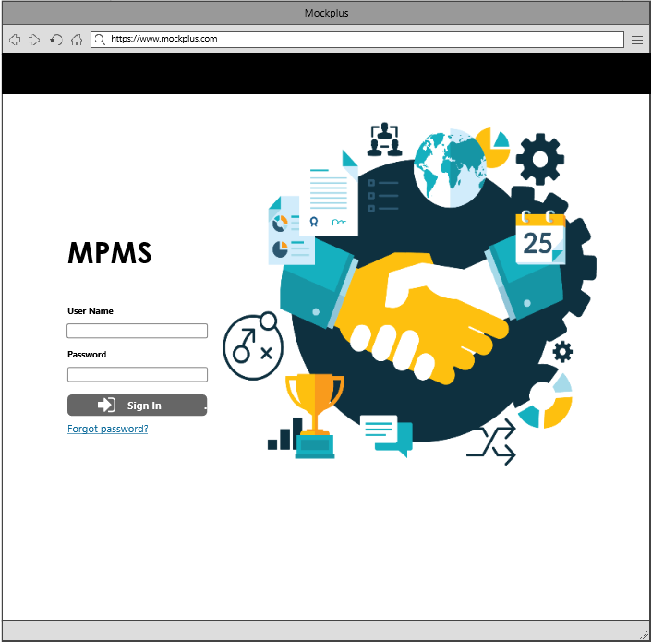

*MPMS Login Page*

# **3 Account Recovery**

* If the user forgot his/her password/account, there will be a forgot password/account link below the sign in button, wherein the user shall be redirected to a page to recover the account. The user must enter the email to search his/her account.

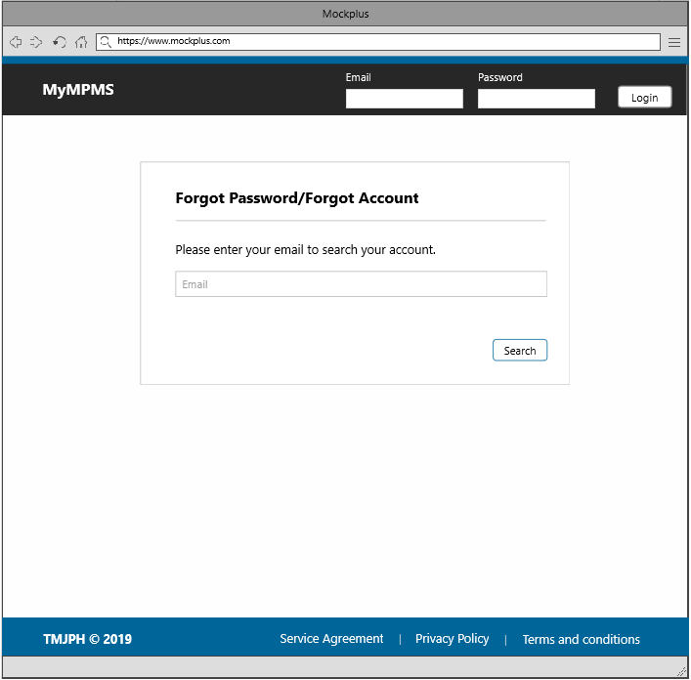

Find account

* After the user has find his/her account, there will be a confirmation section wherein the user needs to verify. The reset account link will be submitted to the user’s email account.

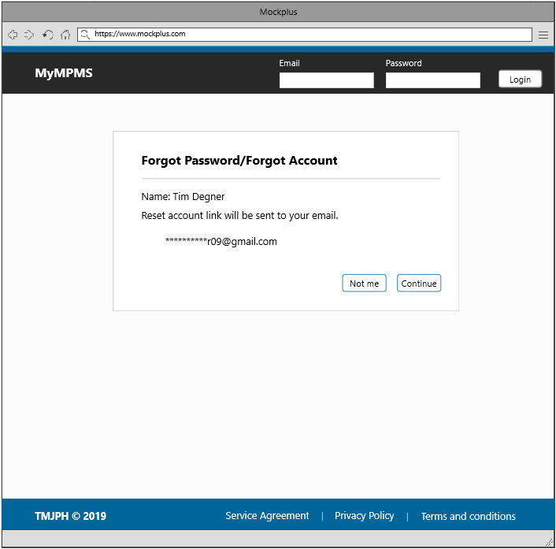

Reset Account Link

# **4 Admin Landing Page**

The admin has the capability to view everything in the system, such as the list of clients, contracts, services, pricing, authorization, agencies and users of the system. The admin also has the capability to create a new agency information, user information and handles security settings which will later be shown in this documentation. This section also contains the template for the header and footer.

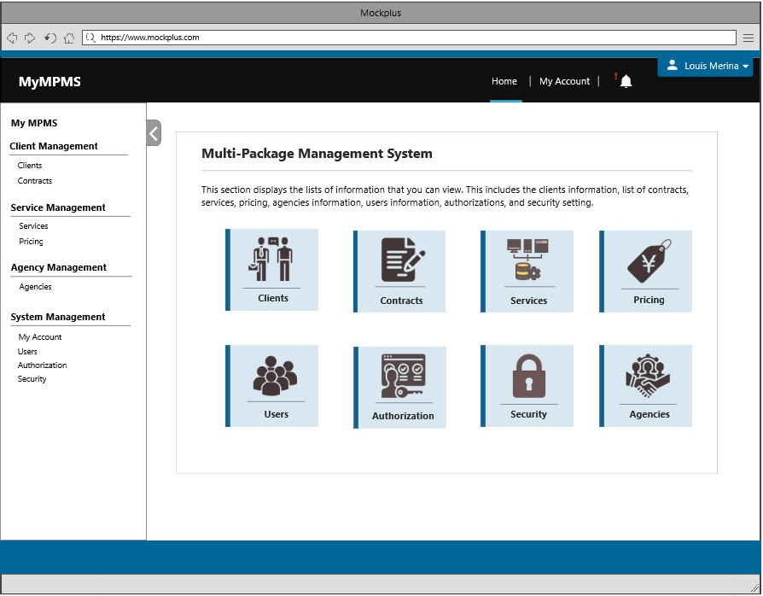

Admin Landing Page

# **5 My account Page**

There are two sections in this page; Account Settings and Contact Information. The Account Settings section shows the account ID, account Name, and the authorization of the user who is currently logged into the system. The next one is the Contact Information section which shows the user’s account name, email and phone number.

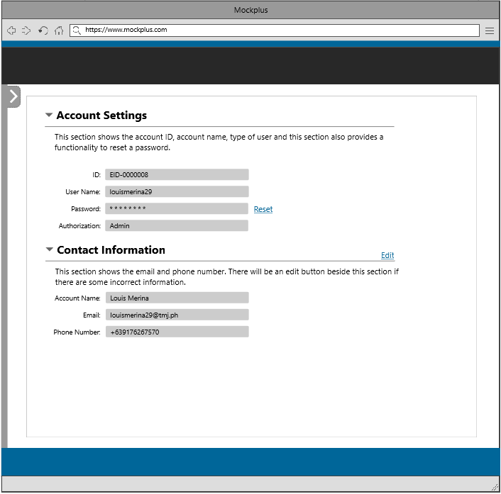

My Account Page

# **6 Client Information**

One of the contents of the admin landing page is Client Information, which basically shows all the clients entered into the system. In this section, there are three functionalities provided to the user: add, edit, and delete which will discussed below. This section consists of the following details: company ID, company name, client contact, and phone number.

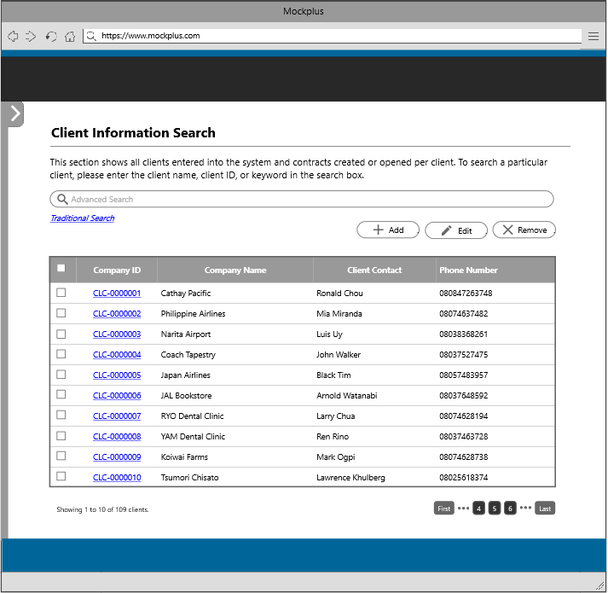

Client Information

Note: There will be three steps in creating a new service information that the user must follow. These steps are adding company information, adding client primary contact, and review section. Following are the steps together with the description.

## 6.1 Add Company Information

The user needs to fill in the following fields such as the company name, address and phone number. The user may include an external client ID, city, state, postal code, country name and website URL.

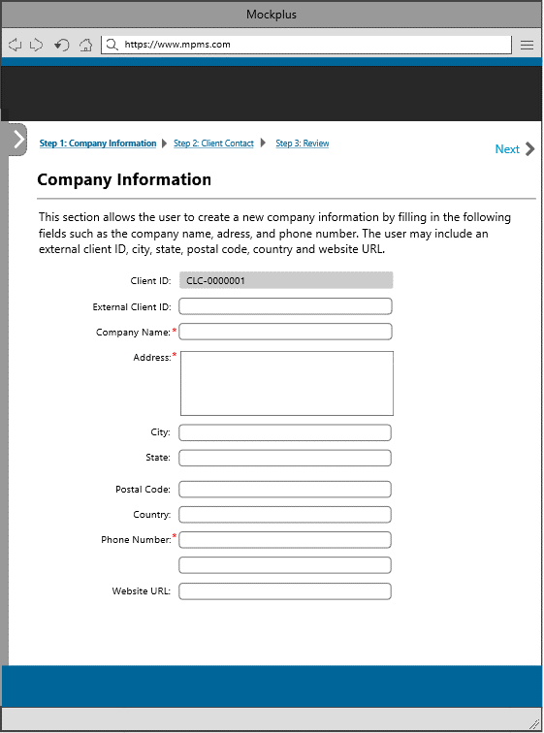

Add Company Information

## 6.2 Add Client Primary Contact

The user also needs to fill in the form for Client Primary Contact, following are the required fields that the user must fill in: name, phone number, email and address. The user may also include: city, state, postal code and country name. The Contact ID will be auto-generated by the system, and it begins with 3 letters (CID-) followed by seven digits incrementing numbers. The user may also include an Alternate Contact which contains the same field as the primary contact.

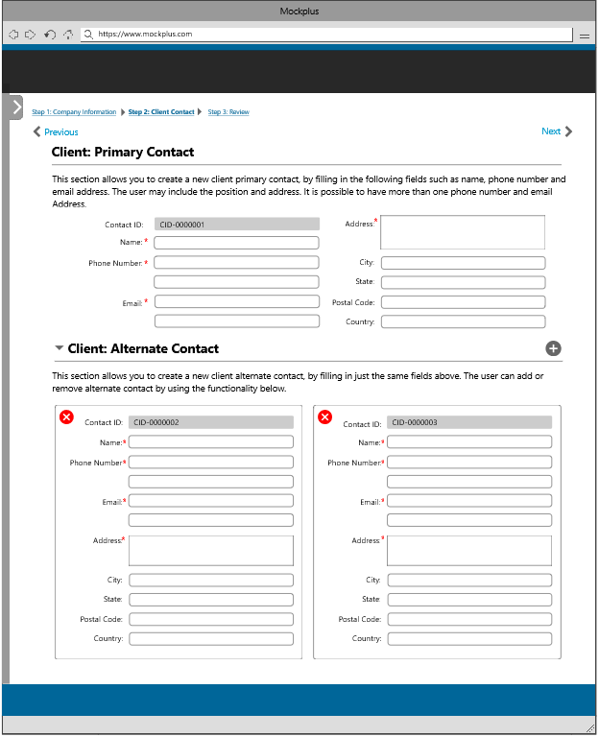

Add Client Primary Contact

## 6.3 Review Client Information(add)

The last step shall be a review section which basically shows all the details that the user has inputted from the two previous steps. This section serves as a review section for the user to check if all the data that he/she has inputted is correct. If there are some corrections, there will be an edit button beside each section.

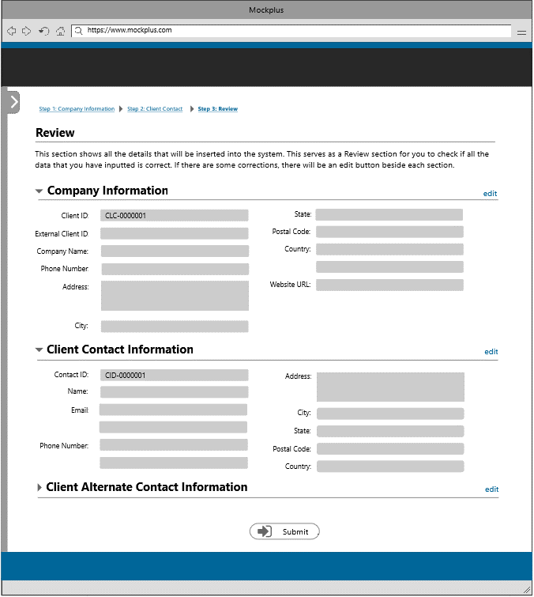

Review Client Information

To update a client information, the user needs to select a client from the table. There will be three steps in updating a client information that the user must follow. The user can update all fields from the form except for the Client ID and Contact ID. All fields from the add functionality is just the same in this section.

## 6.4 Update Company Information

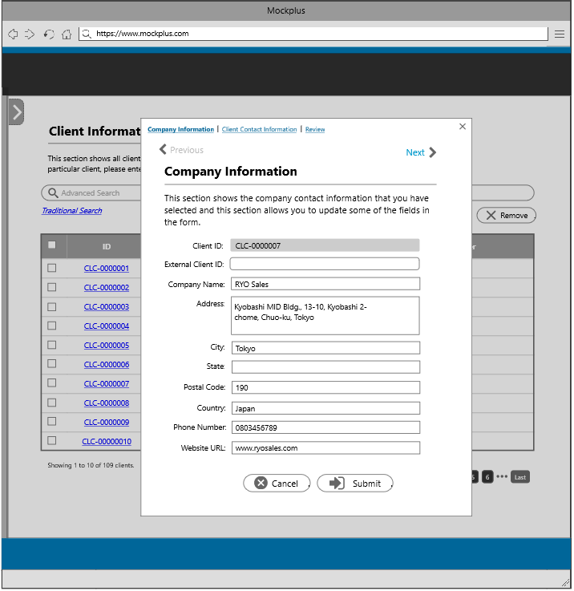

Update Company Information

## 6.5 Update Client Primary Contact

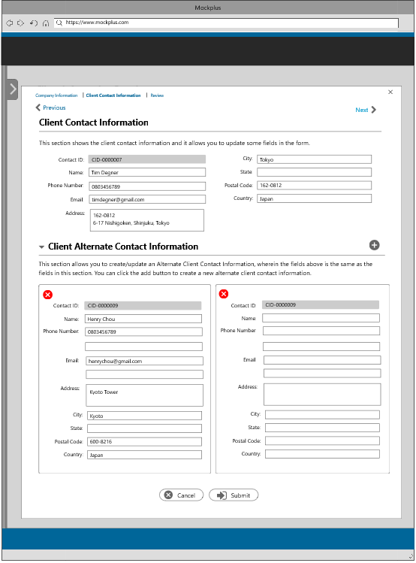

Update Client Primary Contact

## 6.6 Review Client Information(update)

The last step shall be a review section which basically shows all the details that the user has updated from the two previous steps. This section serves as a review section for the user to check if all the data that he/she has updated is correct. If there are some corrections, there will be an edit button beside each section.

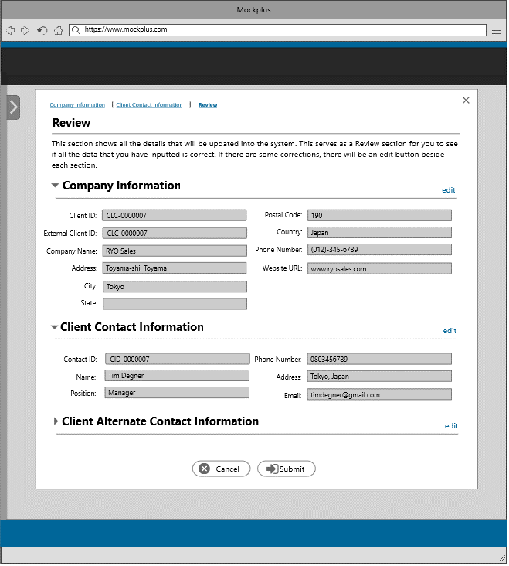

Review Client Information

## 6.7 View Client Information

The user will be able to view the complete client information by clicking on Company ID from the table.

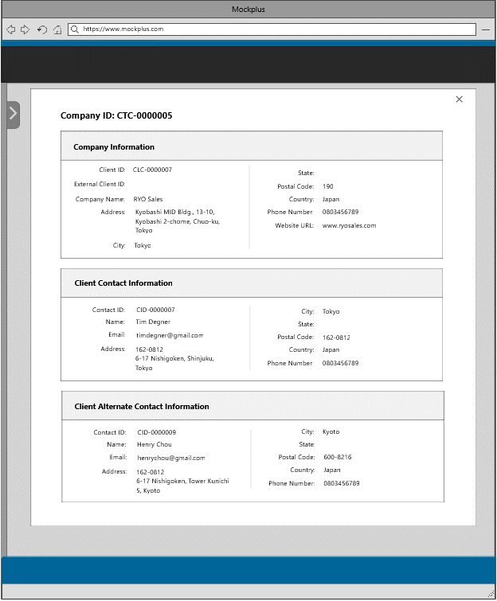

View Client Information

# **7 Contract Information**

The second content from the admin landing page is Contract Information, which basically shows all the clients which have active/inactive/terminated contracts. This section shows the contract ID, contract name, client name, sales personnel and the status of the contract. In this section, there are three functionalities provided to the user: add, edit, and delete which will be discussed below.

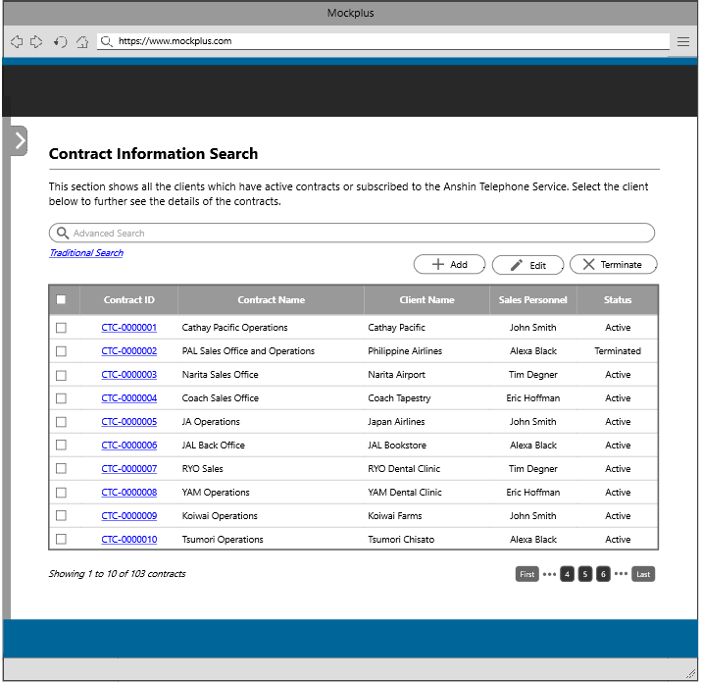

Contract Information

There will be two steps in creating a new contract that the user needs to follow. These steps are adding contract information and review section. Following are the steps together with the description.

## 7.1 Add Contract

In creating a new contract, the user must fill in the required fields in the form such as contract name, by selecting a client, client contact, sales personnel, payment method, contract period and service start date. Other fields will autofill once you have chosen from the dropdown menu. This section also allows you to set a promotional

price, contract period and service start date. The user can also add a service and packages under the contract.

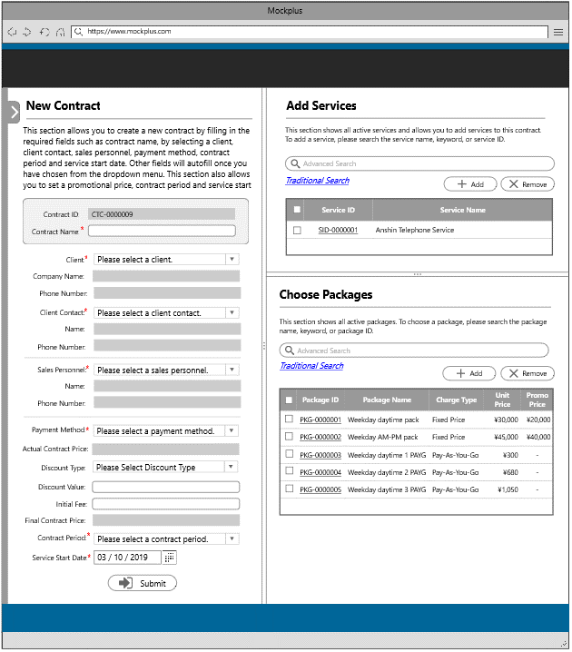

Add contract

## 7.2 Review Contract Information(add)

The last step shall be a review section which basically shows all the details that the user has inputted from the previous step. This section serves as a review section for the user to check if all the data that he/she have inputted is correct. If there are some corrections, there will be an edit button beside each section.

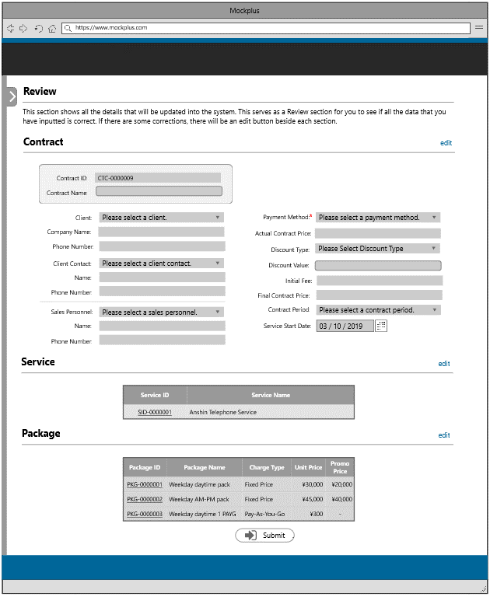

Review Contract

To update a contract information, the user needs to select a contract from the table. There will be two steps in updating a contract information that the user must follow. All fields from the add functionality is just the same in this section.

## 7.3 Update Contract

The user can update all fields from the form except the contract ID. Some of the fields will autofill based on the selected item from the dropdown menu. The user can also update a service or package under the contract.

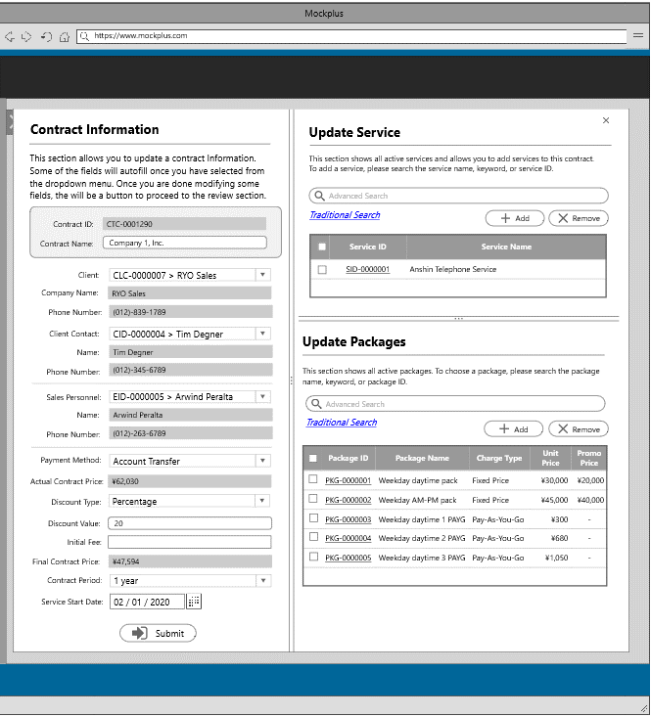

Update Contract

## 7.4 Review Contract Information(edit)

The last step shall be a review section which basically shows all the details that the user has updated from the previous step. This section serves as a review section for the user to check if all the data that he/she has updated is correct. If there are some corrections, there will be an edit button beside each section.

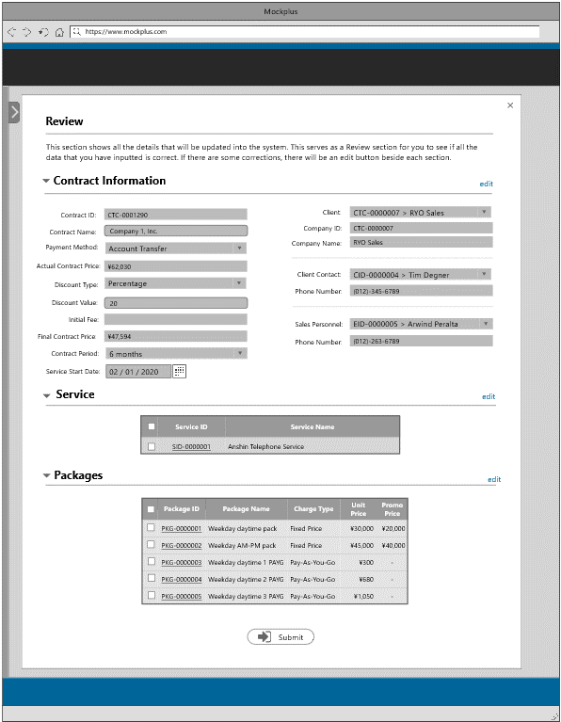

Review Contract

## 7.5 View Contract Information

The user can view the complete contract information by clicking on the Contract ID from the table.

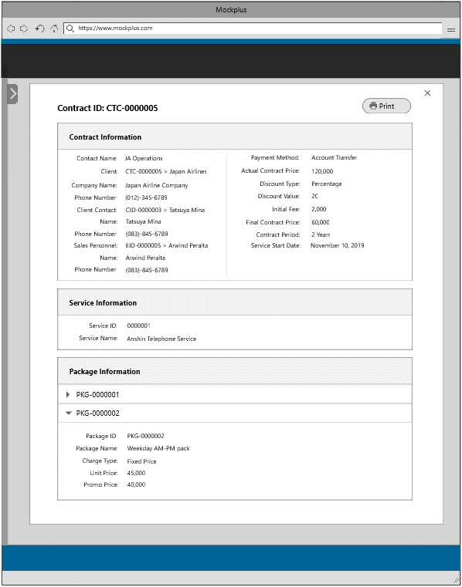

View Contract Information

# **8 Service Information**

The third content from the admin landing page is Service Information, which basically shows all the services and packages from the service. This section shows the service code and service name. In this section, there are three functionalities provided to the user: add, edit, and delete which will be discussed below.

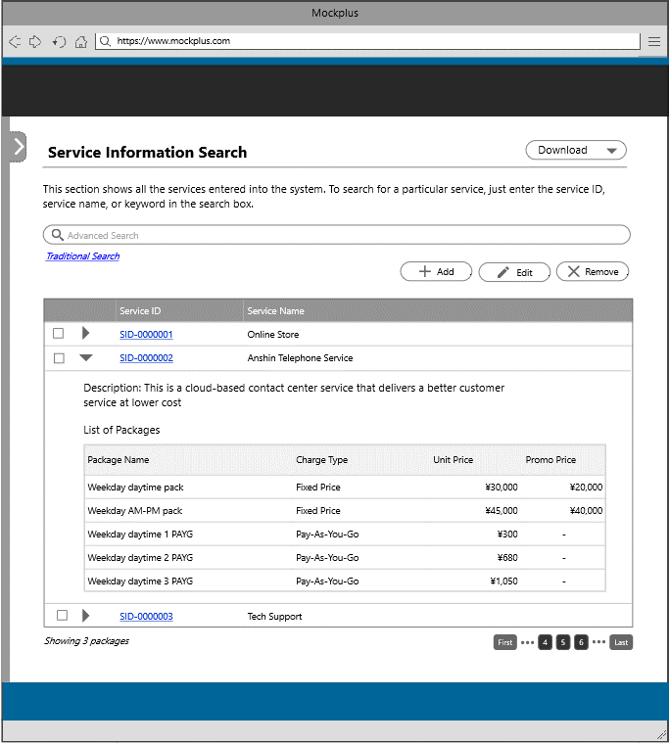

Service Information

There are two steps in creating a new service information that the user needs to follow. These steps are adding service information and review section. Following are the steps together with the description.

## 8.1 Add service information

In creating a new service, the user must fill in the required fields in the form such service name and description. While in creating a new package, the user needs to fill in the package name, package description, unit price and charge type.

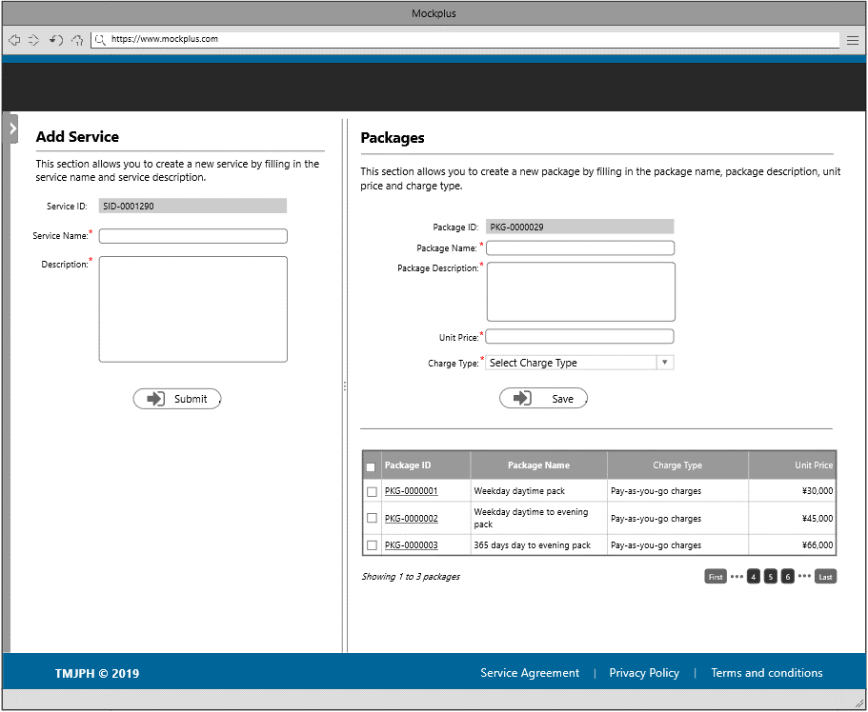

Add Service and Package

## 8.2 Review Service Information(add)

The next step shall be a review section which basically shows all the details that the user has added from the previous step. This section serves as a review section for the user to check if all the data that you have inputted is correct. If there are some corrections, there will be an edit button beside each section.

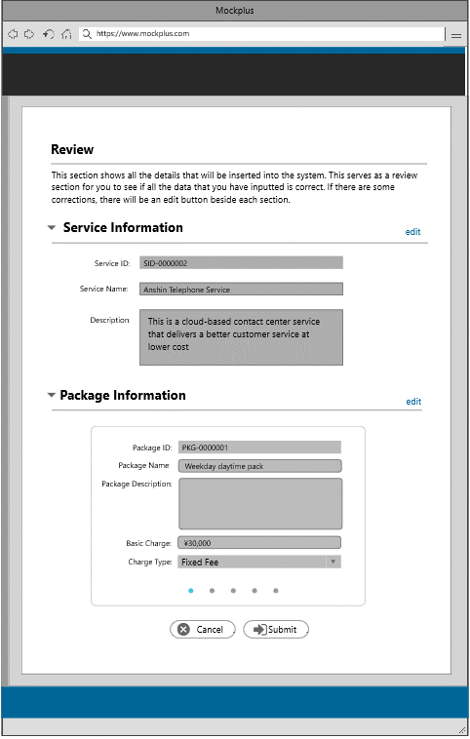

Review Service Information

To update a service information, the user needs to select a service from the table. There will be three steps in updating a service information that the user must follow. All fields from the add functionality is just the same in this section.

## 8.3 Update Service Information

The user can update all fields from the form except from the service ID and package ID. The user can also add a new package, update, and remove a package by using the functionality provided at the top of the package information table.

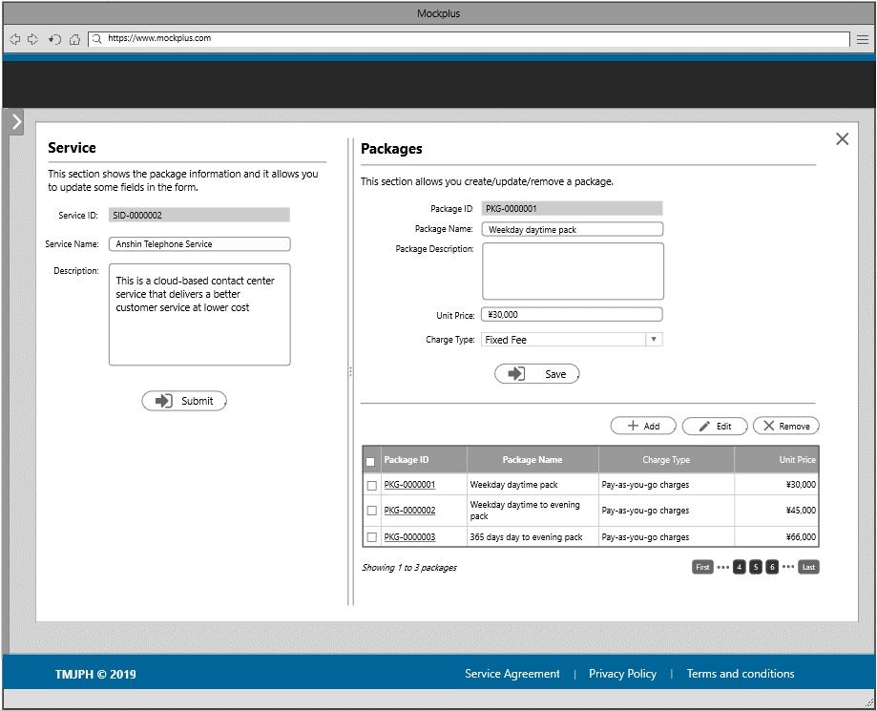

Update Service Information

## 8.4 Review Service Information(edit)

The last step shall be a review section which basically shows all the details that the user has updated from the previous steps. This section serves as a review section for the user to check if all the data that he/she has updated is correct. If there are some corrections, there will be an edit button beside each section.

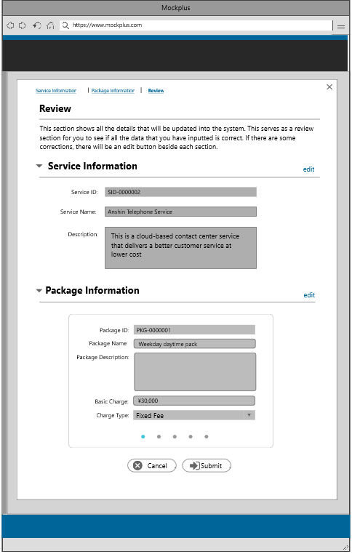

Review Service Information

## 8.5 View Service Information

The user can view the complete service information as well as packages details by clicking on the Service ID from the table.

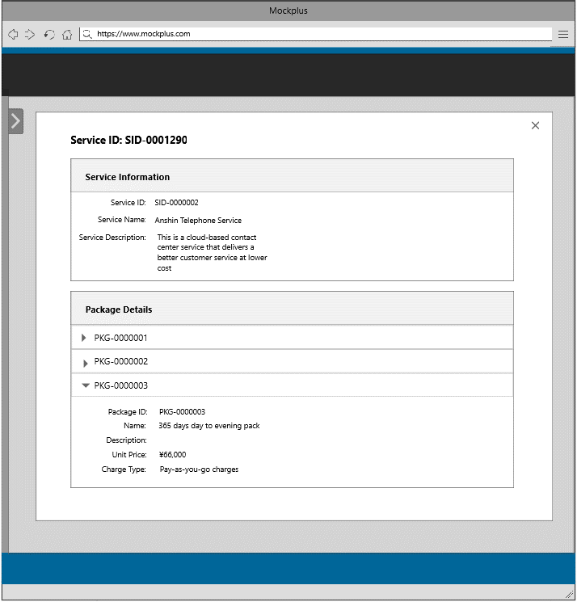

View Service Information

# **9 Pricing**

The fourth content from the admin landing page is pricing Information, which basically shows all price events. This section shows the price event ID, price event name, and all packages under a price event. This section also shows the unit price, promotional price and promotional duration if available. In this section, there are three functionalities provided to the user: add, edit, and delete which will be discussed below.

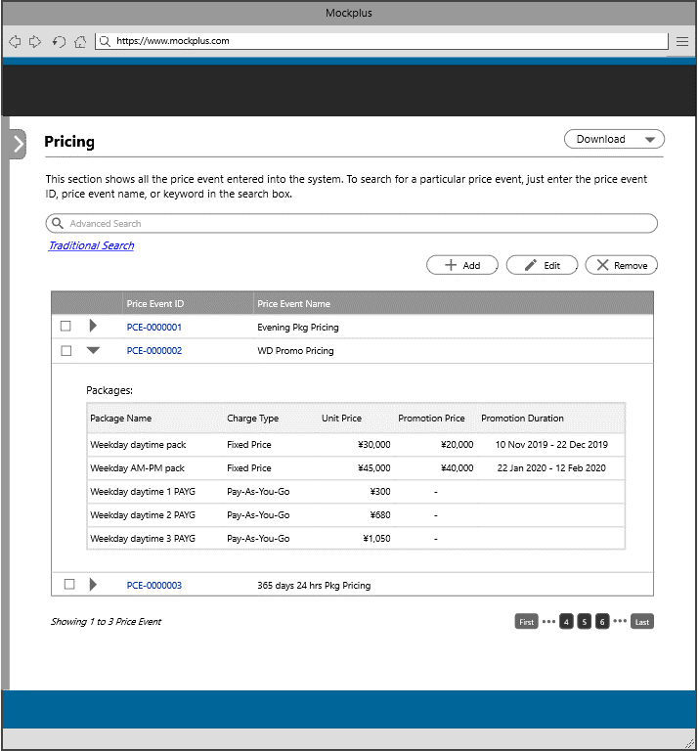

Pricing Information

There are three steps in creating a new price event that the user needs to follow. These steps are filling in the price event name/ selecting a service, selecting a package/unit pricing, and promotional pricing. Following are the steps together with the description.

## 9.1 Select Service

In creating a new price event, the user must fill in the price event name. And the user must choose from the list of services from the right panel.

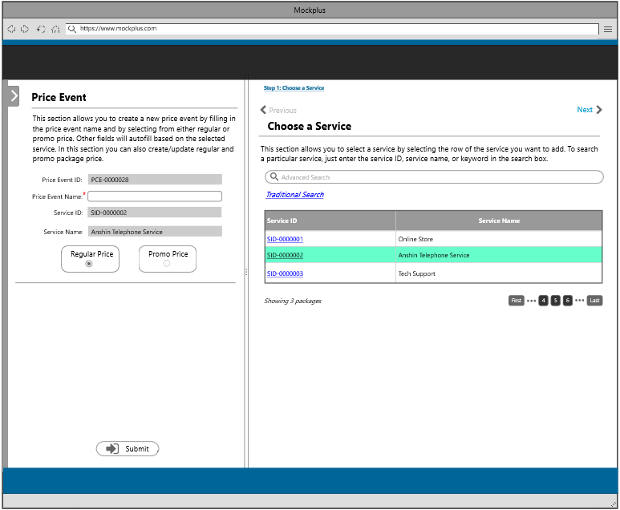

Choose Service

## 9.2 Unit Pricing

This section will autofill based on the selected service and packages. And it allows you to add a new unit price by filling in the new unit price field.

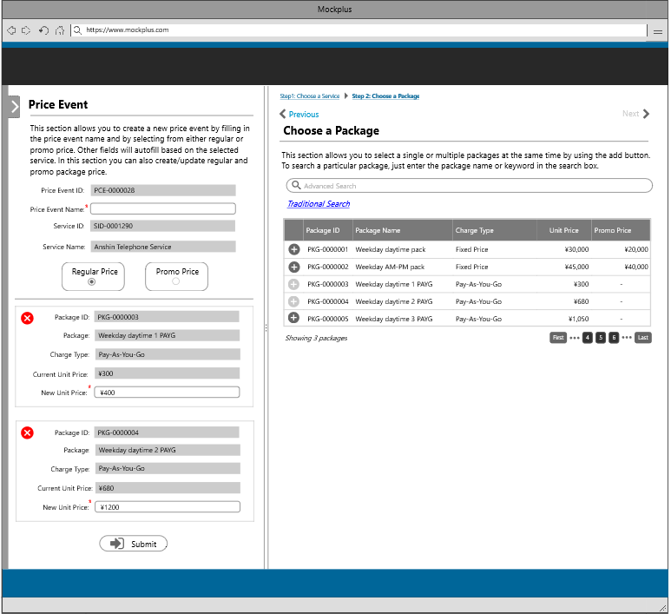

Adding unit price

## 9.3 Promotional Pricing

This section allows you to add promotional price by choosing a discount type and by filling in the discount value and promotional duration. Other fields will autofill based on the calculated value.

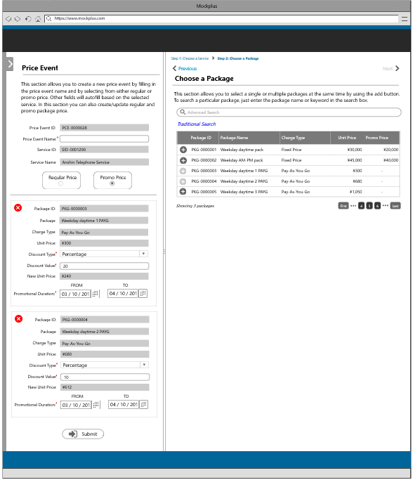

Adding Promotional Price

## 9.4 Review Pricing(add)

The last step shall be a review section which basically shows all the details that the user has inputted from the previous steps. This section serves as a review section for the user to check if all the data that he/she have inputted is correct. If there are some corrections, there will be an edit button beside each section.

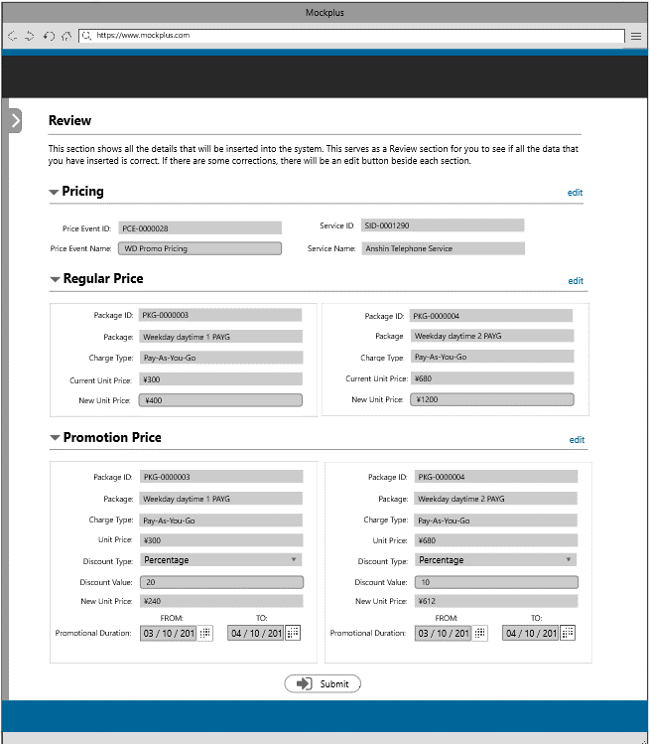

Review Pricing

To update a price event information, the user needs to select a price event from the table. There will be three steps in updating a price event information that the user must follow. All fields from the add functionality is just the same in this section.

## 9.5 Update Unit Price

The user can update all fields from the form except the price event ID. This section allows the user to update a unit price.

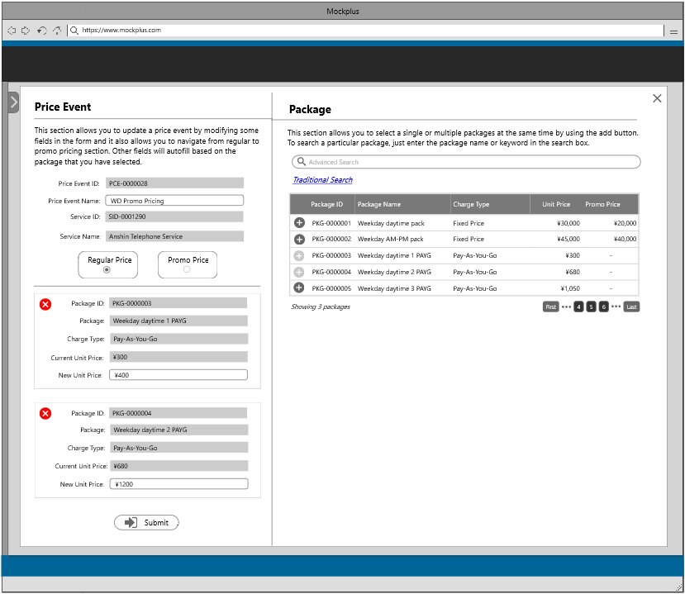

Update Unit Price

## 9.6 Update Promotional Price

This section allows the user to update some of the fields in the form such as the discount value and promotional duration of a package.

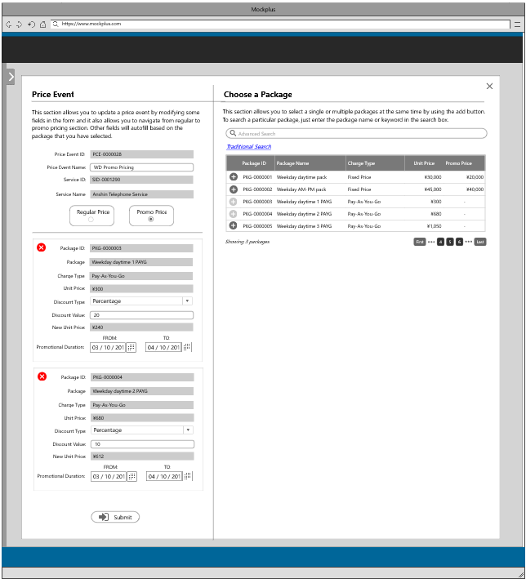

Update Promotional Price

## 9.7 Review Pricing(update)

The last step shall be a review section which basically shows all the details that the user has updated from the previous steps. This section serves as a review section for the user to check if all the data that he/she has updated is correct. If there are some corrections, there will be an edit button beside each section.

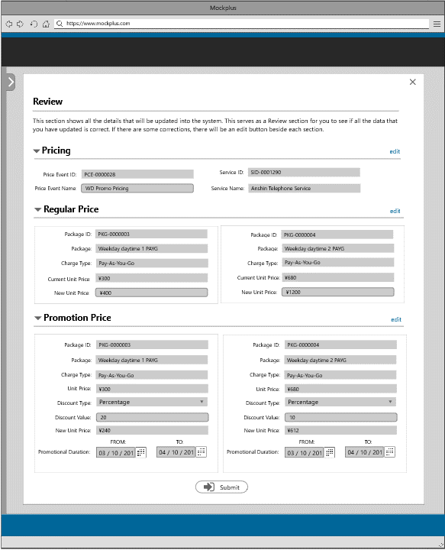

Review Pricing

## 9.8 View Price Event Information

The user can view the complete price event information by clicking on the Price Event ID from the table. This section includes regular and promotion pricing of a package.

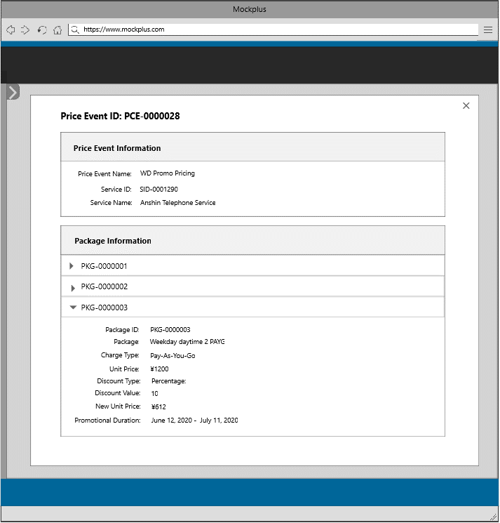

View Price Event Information

# **10 User Information**

The fifth content from the admin landing page is users Information, which basically shows all users entered into system. This section shows the user ID, username, name, email address, and role. In this section, there are three functionalities provided to the user: add, edit, and delete which will be discussed below.

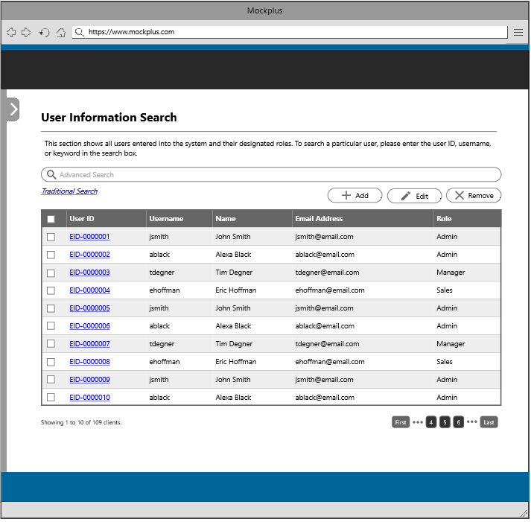

**User Information**

There are two steps in creating a new user information that the user needs to follow. These steps are adding a user information and review section. Following are the steps together with the description.

## 10.1 Add User Information

This section allows the user of this system to create a new user by filling in the username, name, email address and by choosing a role from the dropdown menu.

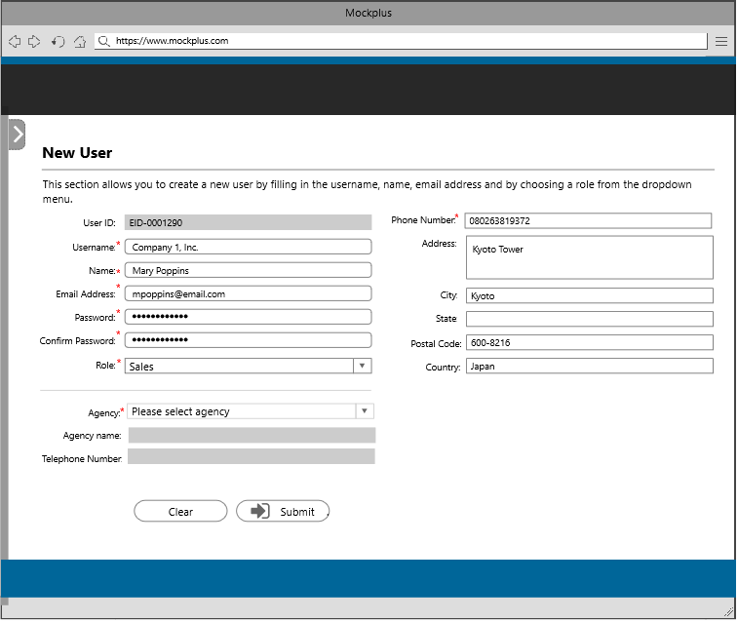

Add User Information

## 10.2 Review User Information(add)

The last step shall be a review section which basically shows all the details that the user has updated from the previous step. This section serves as a review section for the user to check if all the data that he/she has updated is correct. If there are some corrections, there will be an edit button beside each section.

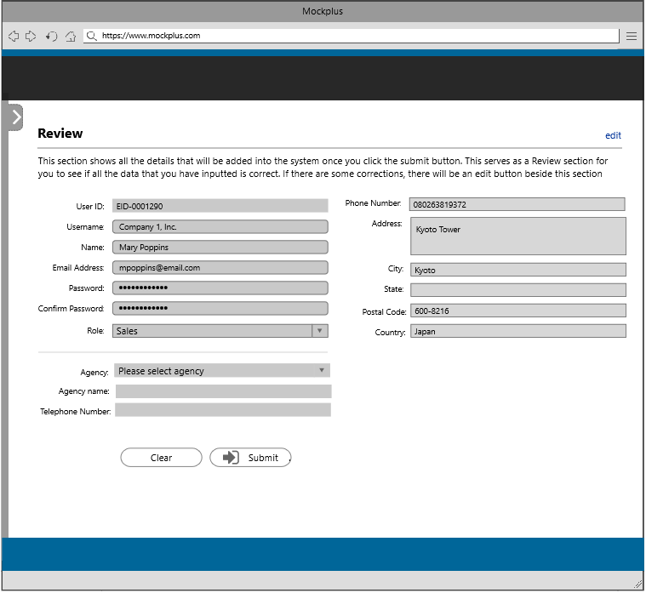

Review User Information

To update a user information, the user needs to select a user from the table. There will be two steps in updating a user information that the user must follow. All fields from the add functionality is just the same in this section

## 10.3 Update User Information

This section shows the user information and you can modify some of the fields such name, email address, role, and agency. This section also includes reset password functionality.

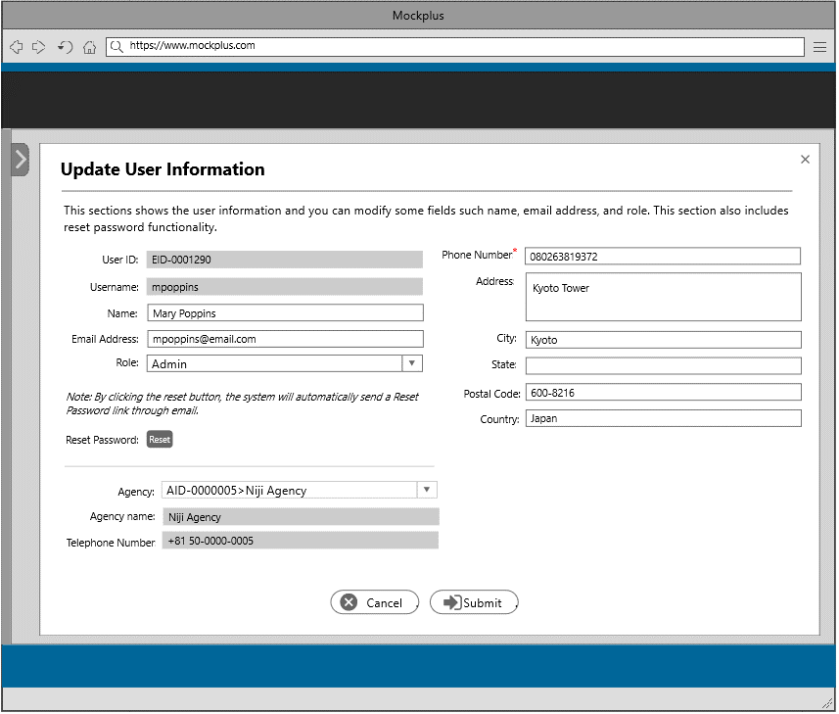

Update User Information

## 10.4 Review User Information(update)

The last step shall be a review section which basically shows all the details that the user has updated from the previous step. This section serves as a review section for the user to check if all the data that he/she has updated is correct. If there are some corrections, there will be an edit button beside each section.

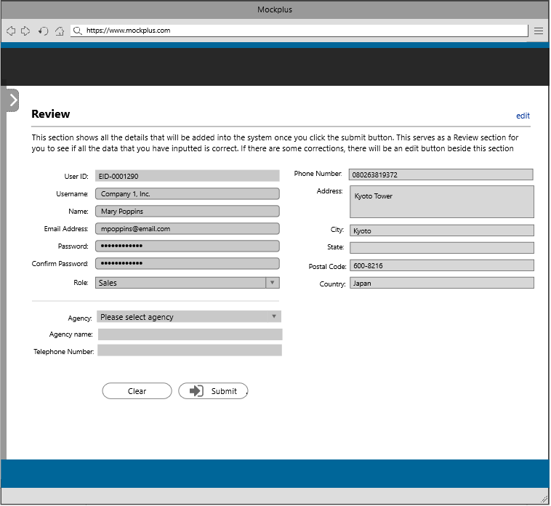

Review User Information

## 10.5 View User Information

The admin can view the complete user information by clicking on the User ID from the table.

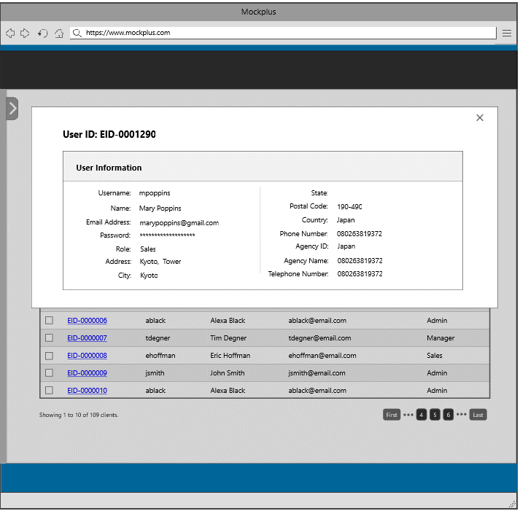

View User Information

# **11 Authorization**

The sixth content from the admin landing page is authorization, which basically shows all the roles entered into the system. This section shows the role ID, role name, description and permission. In this section, there are three functionalities provided to the user: add, edit, and delete which will be discussed below.

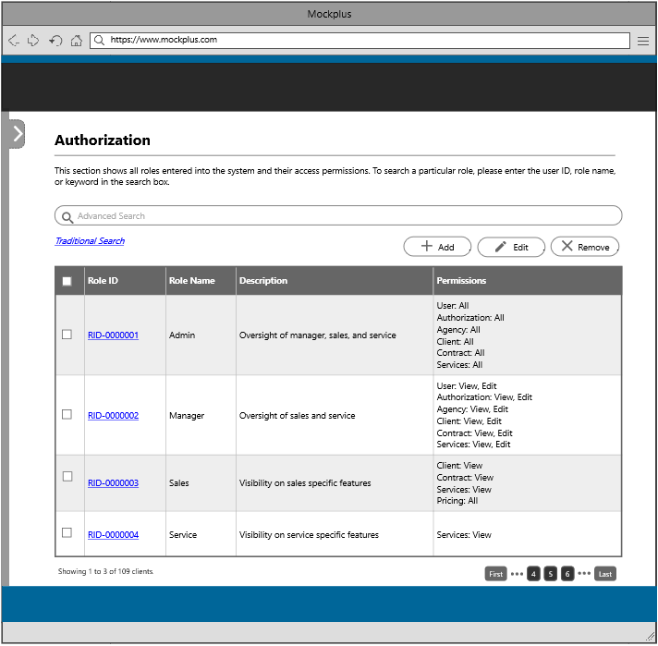

Authorization

## 11.1 Add Role

This section allows the user to add a new role by filing in the role name, description, and by setting the permissions. The roles that was created will be used under the add user tab.

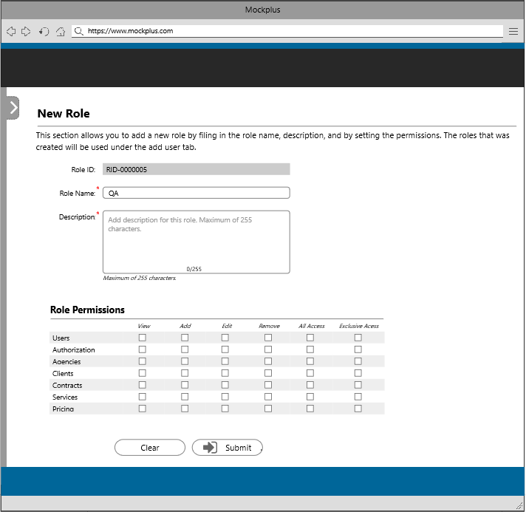

Add Role

## 11.2 Review Role Information(add)

The last step shall be a review section which basically shows all the details that the user has inputted from the previous step. This section serves as a review section for the user to check if all the data that he/she has inserted is correct. If there are some corrections, there will be an edit button beside this section.

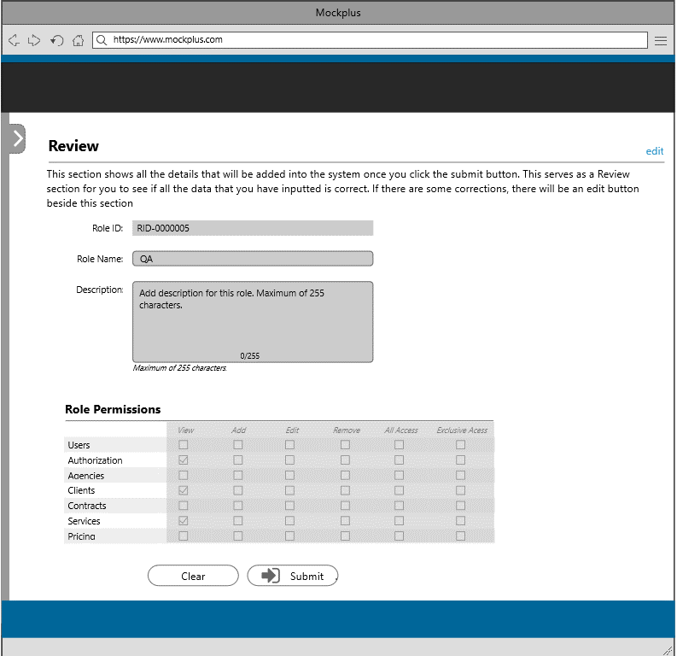

Review Role Information

## 11.3 Update Role

This section allows the user to modify the role name and description. The user can also update the role permission by checking or unchecking the checkbox.

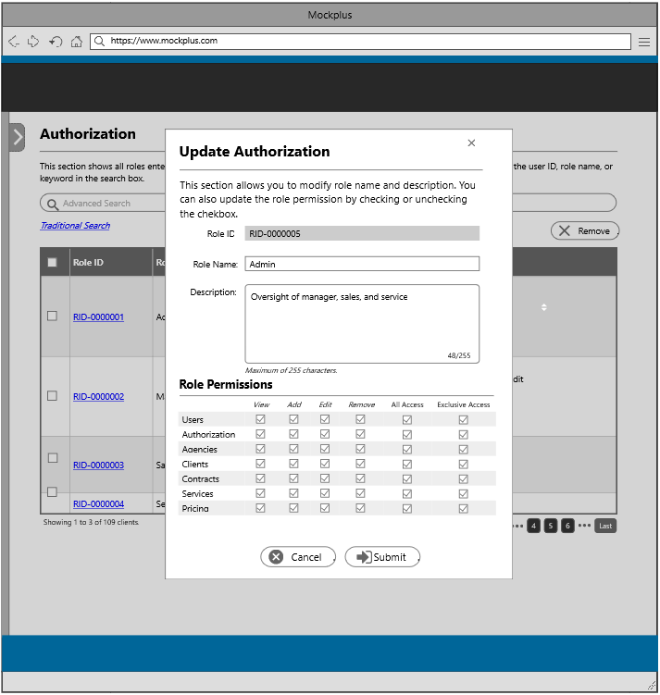

Update Role

## 11.4 Review Role Information(edit)

The last step shall be a review section which basically shows all the details that the user has inputted from the previous step. This section serves as a review section for the user to check if all the data that he/she has inserted is correct. If there are some corrections, there will be an edit button beside this section.

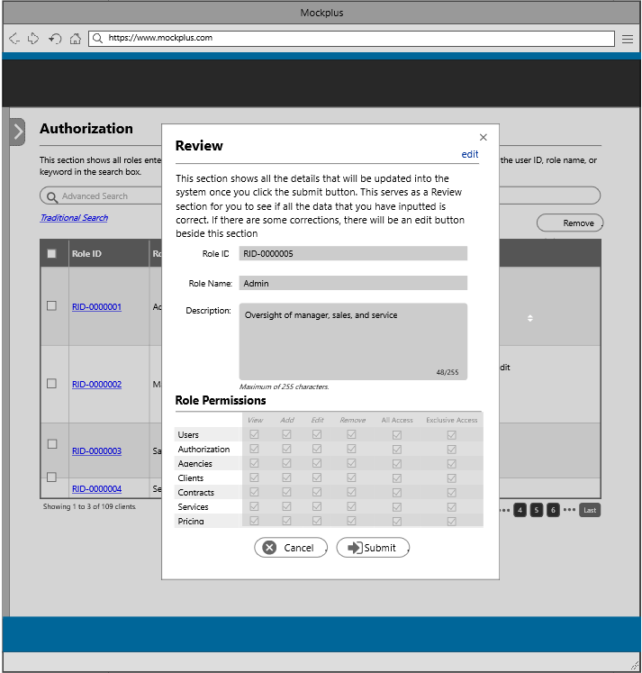

Review Role Information

## 11.5 View Role Information

The user can view the complete role information by clicking on the Role ID from the table.

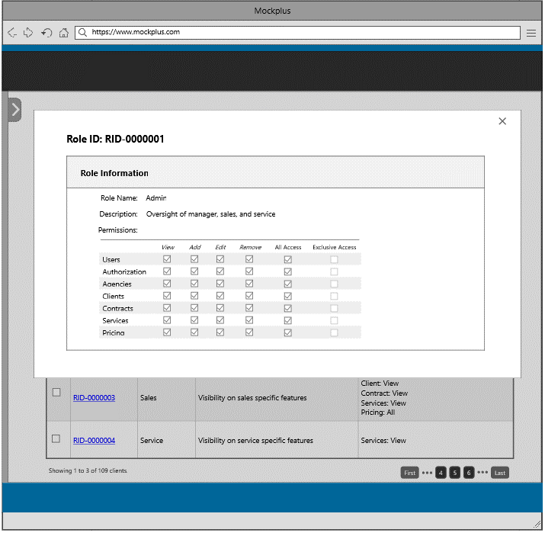

View Role Information

# **12 Security Information**

The sixth content from the admin landing page contains two sections: Password Settings, and Logs. A password setting is a setting that defines the type of password a user can set. Check the options to require and specify a number. Logs section shows the events that are logged, events such as changing of information, operations that you made and system changes.

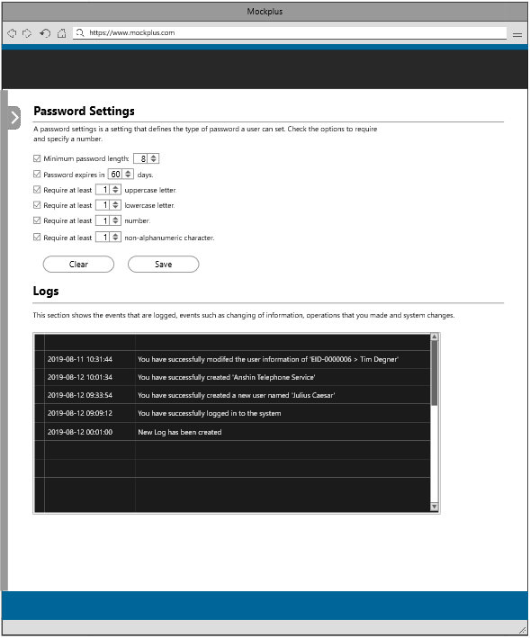

Security Information

## 12.1 Review Security Information

The last step shall be a review section which basically shows all the details that the user has set from the previous step This section serves as a review section for the user to check if all the data that he/she has inserted is correct. If there are some corrections, there will be an edit button beside this section.

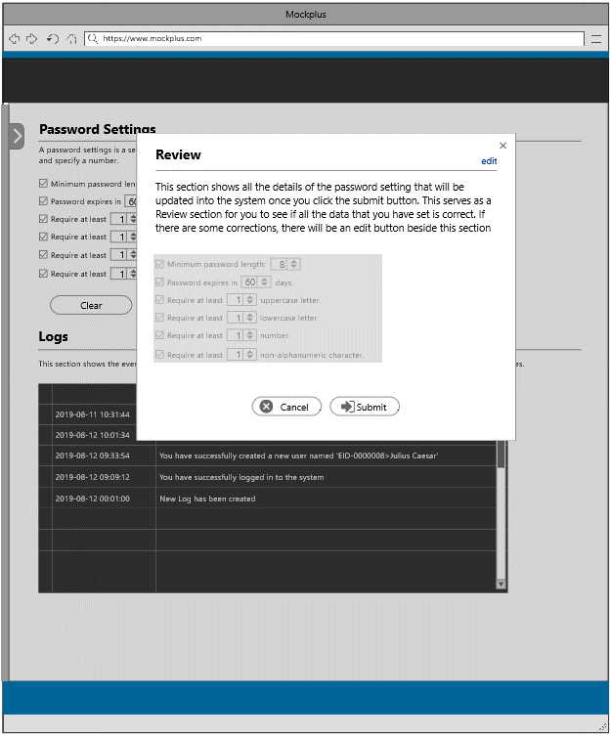

# **13 Agency Information**

The last content from the admin landing page is agency information, which basically shows all agencies entered into the system. This section shows the agency ID, agency name, telephone number, email address and agency address. In this section, there are three functionalities provided to the user: add, edit, and delete which will be discussed below.

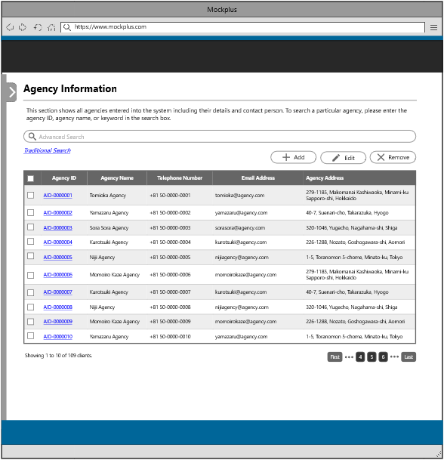

Agency Information

## 13.1 Add Agency Information

This section allows the user to create a new agency by filling in the required fields such as agency name, telephone number, email address, agency address and contract person. The user may also include the website URL.

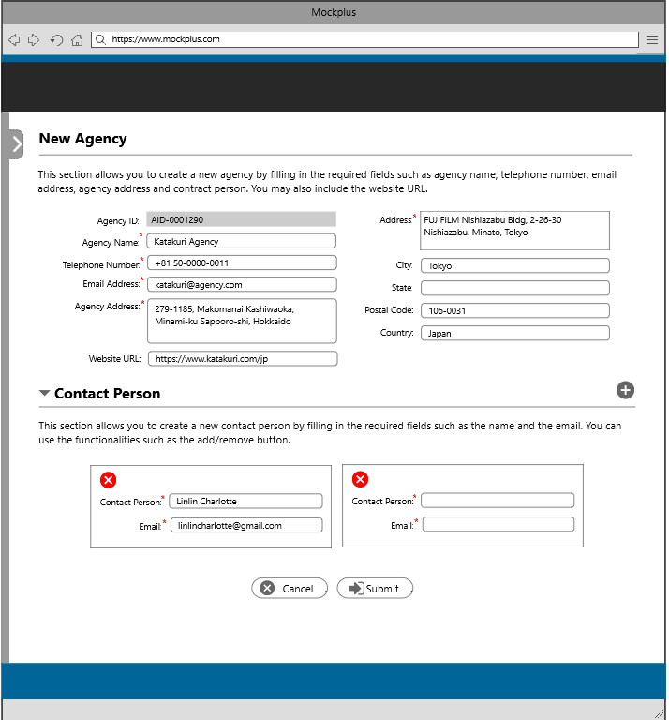

Add Agency Information

## 13.2 Review Agency Information(add)

The last step shall be a review section which basically shows all the details that the user has inserted from the previous step This section serves as a review section for the user to check if all the data that he/she has inserted is correct. If there are some corrections, there will be an edit button beside this section.

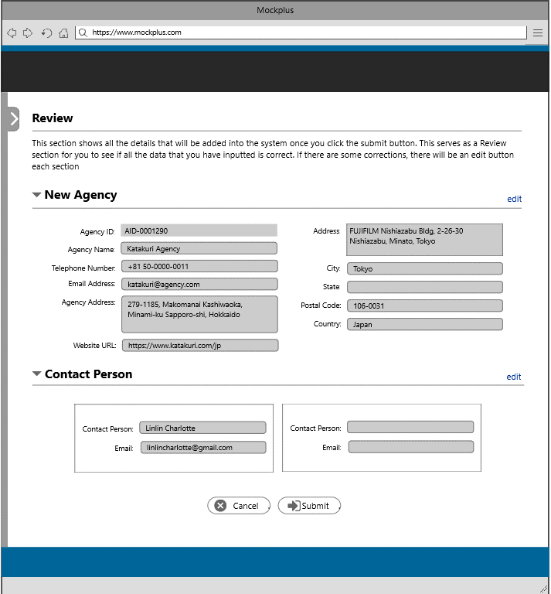

Review Agency Information

## 13.3 Update Agency Information

This section shows the agency information and this section allows the user to modify some of the fields in the form.

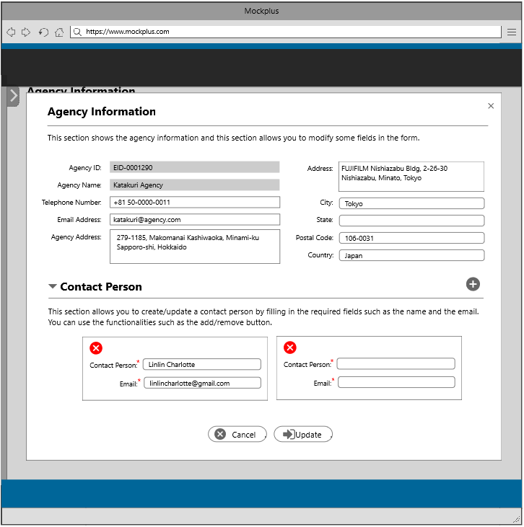

Update Agency Information

## 13.4 Review Agency Information(edit)

The last step shall be a review section which basically shows all the details that the user has updated from the previous step. This section serves as a review section for the user to check if all the data that he/she has updated is correct. If there are some corrections, there will be an edit button beside this section.

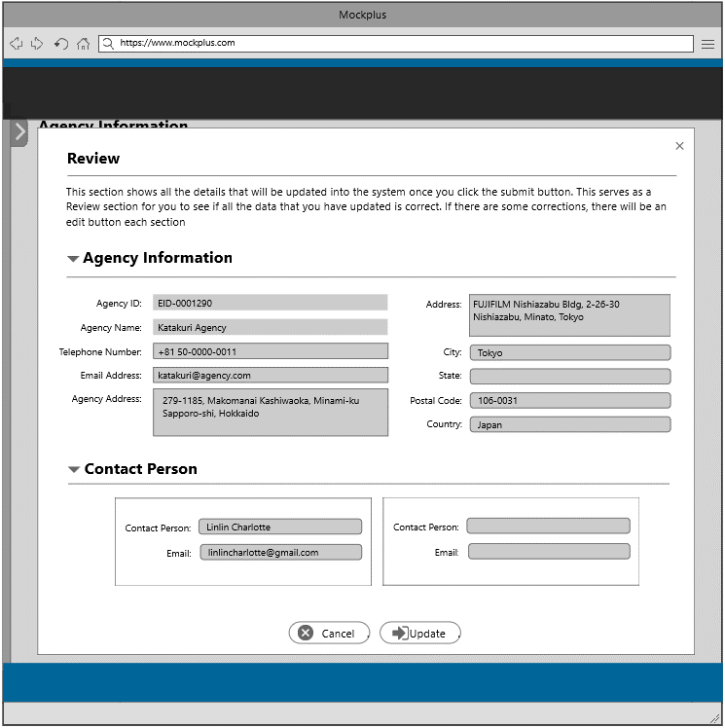

Review Agency Information

## 13.5 View Agency Information

The user can view the complete agency information by clicking on the Agency ID from the table.

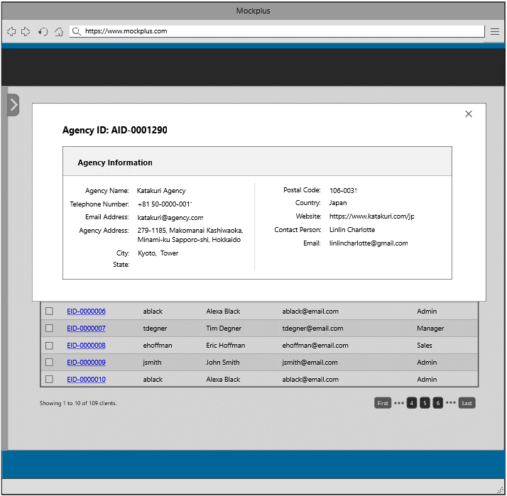

View Agency Information